Lecture 25

**SAN on-prem & SAN in Cloud (Live Session 08 October 2022)**

SAN



* .
* 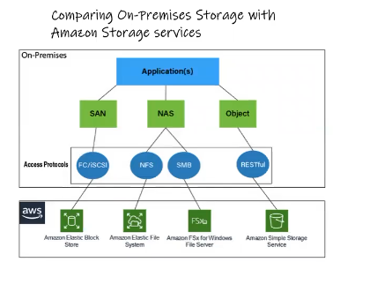
* 1st thing is to configure RAID
* 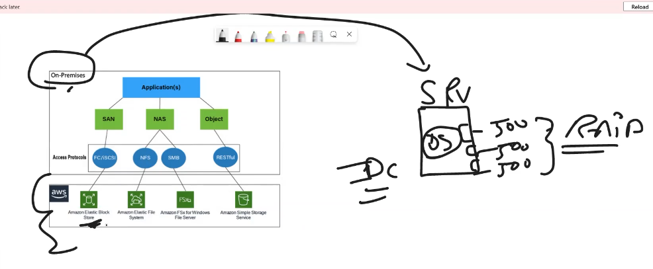
* 3 HDs 500Gbs each (the HDs on server will be used for just OS)
* RAID 1 🡪 mirror (2 HDs) 🡪 500 Gbs
* 1 HD as hot Swap
* After Server is setup
* A requirement is 🡪 for Database 🡪 they need a mount point (1 Tb)
* (3 HDs are used for server) 🡪 in this case SAN comes in business.
* 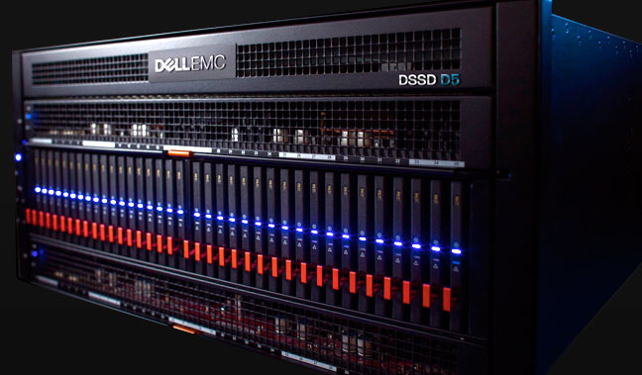
* SAN stands for Storage Area Network. It is a specialized high-speed network that provides block-level access to shared storage devices, such as disk arrays and tape libraries, to multiple servers. SANs are typically used in enterprise environments where large amounts of data need to be stored and accessed by multiple servers, applications or users.
* SANs are designed to provide high availability and scalability, with redundant components and failover capabilities to ensure data access even in the event of component failures. They can support a variety of storage technologies and protocols, such as Fibre Channel, iSCSI, and FCoE, and can be configured in different topologies, such as mesh, ring, or tree.
* SANs can offer several benefits, including centralized storage management, improved data availability and performance, and simplified backup and recovery. They are commonly used in data-intensive applications, such as databases, virtualization, and high-performance computing, as well as in cloud and storage service provider environments.
* 1 Tb is provided by SAN for **“database”** requirement.
* 4 HDs of 350 Gbs each are available from SAN.
* The **TASK** is to bring these 4 disks to server for “database” usage.
* ***SAN connects to Server with Fibber Channel.***
* NAS uses Network Cable for connection. 🡪 it is not “block storage”.
* **HBA** card connects SAN to server.
* **HBA Card 🡪** every HS had two ports (it manages Inupt-Output (I/O) bus)
* **Qlogic , amolant. adaptic** are vendors of these cards.
* *Different commands* to connect to fibre channel.
* These cards carry WWN Nos that are used by the SAN to recognize it. 🡪 similarly Network Card has a unique MAC ID.
* Admin provides these WWN No to storage Admin for connectivity.
* **HBA Card** Carry **WWN Nos** and the ports (two Ports on each card) has **WWP Nos.** (World Wide Port No) (HEXA Decimal Nos)
* 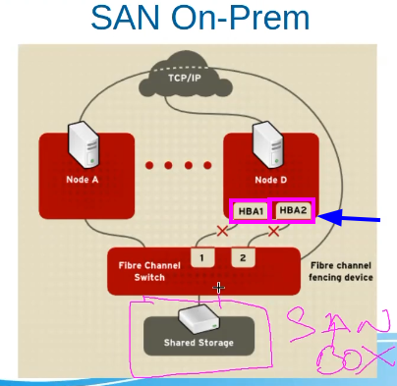
* .
* SAN Admin will provide (***He has 3 Disks in SAN)*** 1Tb disk for Linux Admin (will ask for WWN No of the Server)
* Storage Admin will configure “ldev” on this 1 Tb disk.
  + Will **map** (it means these 4 disks are only visible to these WWN Nos (that is our server in this case)) 4 Disks with WWN Nos provided by Linux Admin.
  + Suppose there is another server 🡪 these 4 disks will not be visible to that server. 🡪 ***because its WWN No. is not mapped with these disks.***
  + *SAN has a console for this purpose.*
* LUNS (Logical Unit Number) are from “ldev”
* For 1 Tb 🡪 storage Admin will create.
  + 250 Gb lv1
  + 250 Gb lv2
  + 250 Gb lv3
  + 250 Gb lv4
* *These “LDEV” are “LUN” for Linux Admin*.
* 4 LUNS are for Server.

**Settings on Server**

* Admin will fire 2 commands. (to discover and scan 4 disks) 🡪 *there is also script provided by Red Had for this purpose.* Another option is to reboot the server
  + After these commands these disks will be visible in server.
  + As /sdb, /sdc, /sde
* ***Open fibre software will do the job with ISCSI for practical purpose.***
* **\* those companied that can’t affort fibre channel they use this method which works on TCP/IP.**
* **SAN storage = Target**
* **Server (Node) = initiator**
* 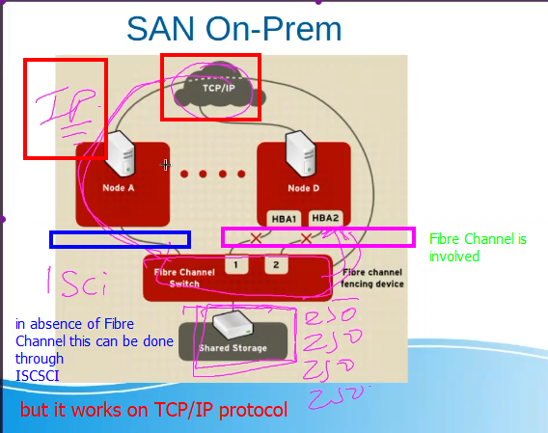
* .
* **Fibre Channe = Block Storage**
* **iSCSI = Network Storage**

Block storage and network storage are two different types of data storage technologies used in computing systems.

**Block storage** refers to a type of data storage that breaks data into fixed-sized blocks and stores them in a specific location on a hard drive or solid-state drive. Each block is assigned a unique address, and the storage system uses these addresses to retrieve the data quickly. Block storage is commonly used in storage area network (SAN) and direct-attached storage (DAS) systems.

On the other hand, **network storage** refers to a type of data storage that is accessed over a network, such as a local area network (LAN) or a wide area network (WAN). Network storage can be further divided into two types: file storage and object storage.

**File storage** allows users to store and access files on a shared network location, like a file server or network-attached storage (NAS) device. The files are organized into a hierarchical directory structure and are accessed using standard file protocols, such as Server Message Block (SMB) or Network File System (NFS).

**Object storage**, on the other hand, stores data as objects, which can be accessed using unique identifiers. Each object contains both data and metadata and can be accessed using a web-based application programming interface (API). Object storage is commonly used for storing large amounts of unstructured data, such as video or image files, and is often used in cloud storage systems.

* .

To fine HBA Card installed on Server

|  |
| --- |
| To find the HBA (Host Bus Adapter) card installed on a RHEL (Red Hat Enterprise Linux) system, you can use the **lspci** command with grep to filter for the HBA card.  Here are the steps:  Open a terminal window on your RHEL system.  Run the following command to list all the PCI devices installed on your system:  **lspci**  This will display a long list of devices. To filter for the HBA card, you can use the following command with grep:  **lspci | grep -i hba**  This will display only the devices that have "HBA" in their description. The **-i** option in grep makes the search case-insensitive.  Look for the entry in the output that corresponds to your HBA card. The entry will typically include the name and model of the HBA card.  Note: If the HBA card is not detected by the system, it may not be installed properly or may be defective. |

* .
* To fine HBA Port
* 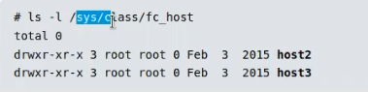
* .
* 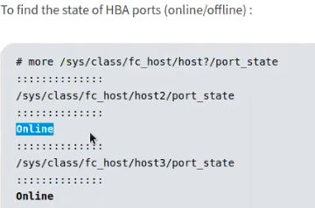
* .
* 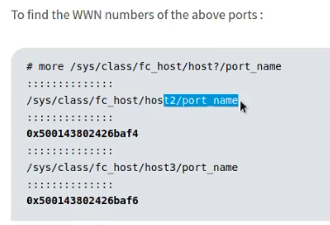
* .
* Same configurations can be done through a tool
* 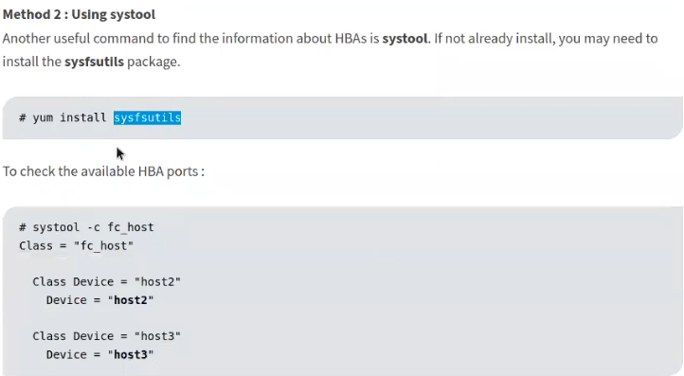
* .
* Graphical user interface, text, application, chat or text message

  Description automatically generated
* .
* Working explained.
* 

**how to scan/detuct new LUNs and SCSI disks in Linux**

In Linux RHEL, you can use the following steps to scan and detect new LUNs and SCSI disks:

Identify the Host Bus Adapter (HBA) name by running the following command:

# ls /sys/class/scsi_host/

Once you have identified the HBA name, scan the SCSI bus by running the following command:

# echo "- - -" > /sys/class/scsi_host/hostX/scan

Replace **hostX** with the actual HBA name.

Use the **fdisk** command to check if the new disk/LUN is detected. Run the following command:

# fdisk -l

This command should show you the new disk/LUN along with its size.

Create a partition on the new disk/LUN using the **fdisk** command. For example:

# fdisk /dev/sdb

This will open the **fdisk** utility for **/dev/sdb**. Use the **n** command to create a new partition, specify the partition type, set the partition size, and then save the changes using the **w** command.

Run the **partprobe** command to inform the kernel of the partition table changes:

# partprobe

Format the new partition with a file system of your choice. For example, to format it with ext4:

# mkfs.ext4 /dev/sdb1

Create a mount point for the new file system and mount it:

bashCopy code

# mkdir /mnt/newdisk # mount /dev/sdb1 /mnt/newdisk

Replace **/mnt/newdisk** with the actual mount point.

Your new disk/LUN should now be detected, partitioned, formatted, and mounted in Linux RHEL.

* .
* Sir Kazim showed this web page,
* .

|  |
| --- |
| Method-1: Scanning SCSI disks and LUN in Linux  ‘**sysfs**‘ filesystem is a pseudo-file system which provides an interface to the kernel data structures.  Files under sysfs provides an information about devices, kernel modules, filesystems and other kernel components.  **sysfs**file system is commonly mounted at “/sys”. Typically, it is mounted automatically by the system.  Each scsi host device can be scanned using the echo command, as shown below.  echo "**- - -**" > /sys/class/scsi_host/host[n]/scan  Three dashes (- – – ) in the above command refers to wild card option which in turn rescan everything.  echo "c t l" > /sys/class/scsi_host/host[n]/scan  Values mentioned in the above wild card will scan the following parameters.  **c –** Channel on the HBA  **t –** SCSI target ID  l**–** LUN ID  **n –** HBA number  Run the below command to find all the host bus number in your system.  ls /sys/class/scsi_host  host0 host1 host2  Once the host bus number has been verified, run the following command to discover new disks.  echo "- - -" > /sys/class/scsi_host/host0/scan  echo "- - -" > /sys/class/scsi_host/host1/scan  echo "- - -" > /sys/class/scsi_host/host2/scan  Above task can also be performed, by using “for loop” as a single command.  for host in `ls /sys/class/scsi_hosts`; do echo "Scanning $host...Completed"; echo "- - -" > /sys/class/scsi_hosts/$host/scan; done  Scanning host0...Completed  Scanning host1...Completed  Scanning host2...Completed  LUN ID which has been detected in the server, can be verified by using [**ls command**](https://www.2daygeek.com/linux-unix-ls-command-display-directory-contents/) as below.  ls /dev/disk/by-id | grep -i "LUN ID"  Method-1(a): Scanning FC LUNs in Linux  Follow the below procedure to rescan the newly added FC LUNs.  To identify the number of HBA adapters, run. Note the number of hosts available on the server in order to scan them.  ls /sys/class/fc_host host0 host1 host2 host3  Run the command against each FC channel to scan the LUNs. Make a note, just replace with your actual FC host value instead.  echo "- - -" > /sys/class/fc_host/host0/issue_lip  echo "- - -" > /sys/class/fc_host/host1/issue_lip  echo "- - -" > /sys/class/fc_host/host2/issue_lip  echo "- - -" > /sys/class/fc_host/host3/issue_lip  If you find many FC hosts, use the for loop to scan all at once.  for host in ls /sys/class/fc_host/;do echo "- - -" >/sys/class/fc_host/$host/issue_lip; done |

* .

3rd Method would be to reboot the server.

* ***Tip:-*** if after these steps LUNs are still not visible, it means (chances are high) the issue is with storage
* ***Troubleshooting*** 
  + ***Check if HBA port is up?***
  + Storage Mapping is visible?
  + RAID 🡪 if working normally.
  + If LVM is configured, check if it is running normally.
* .

**Same is available on AWS**

* As EBS (Elastic Block Storge)
* All steps are easy and same as done before.
* The new thing is if the size of the volume is increased, the following command must be executed to map the new (increased) volume in EC2 instance.
* For xfs
* 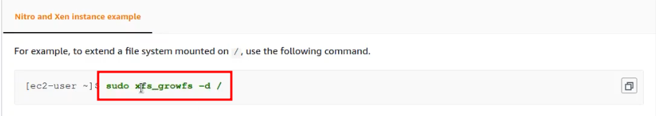
* For ext4
* Graphical user interface, text, application, email

  Description automatically generated
* .
* 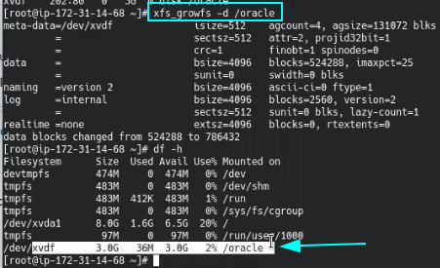
* .

Same configuration on EC2 Instance for Windows Machine.

* 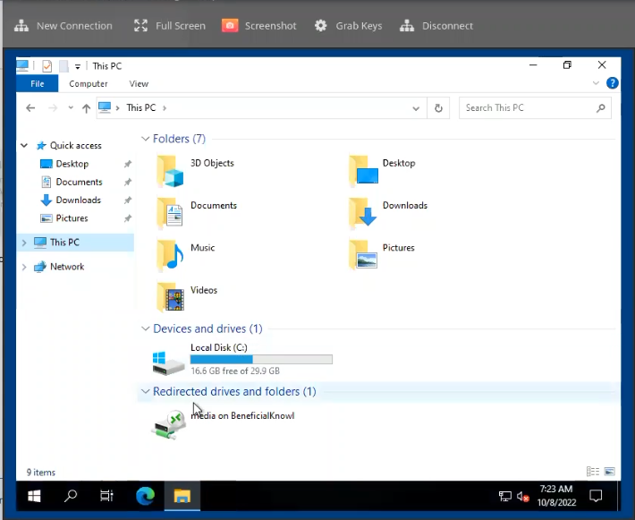
* We need to add another disk as per requirement.
* Create 2Gb volume on AWS
* Disk management on Windows
* 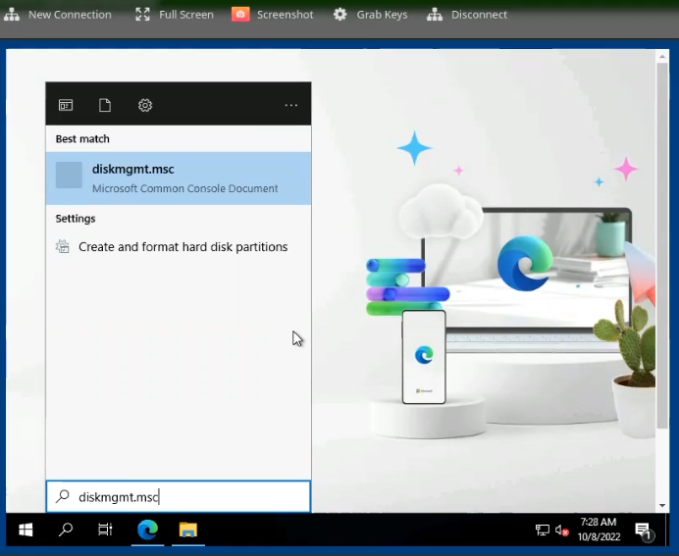
* .
* 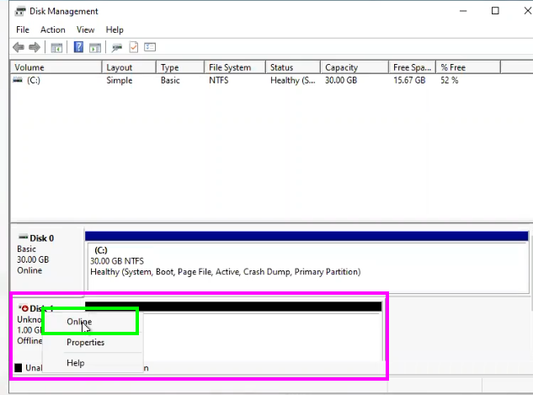
* .
* Right click 🡪 Online
* .
* Graphical user interface, text, application, email

  Description automatically generated
* .
* Initialize
* .
* Here create the New simple volume/partition and format it accordingly.
* 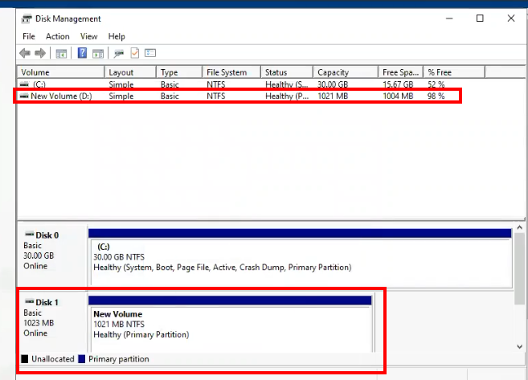
* .
* New volume added.
* Graphical user interface, text

  Description automatically generated
* If we need more storage .
* 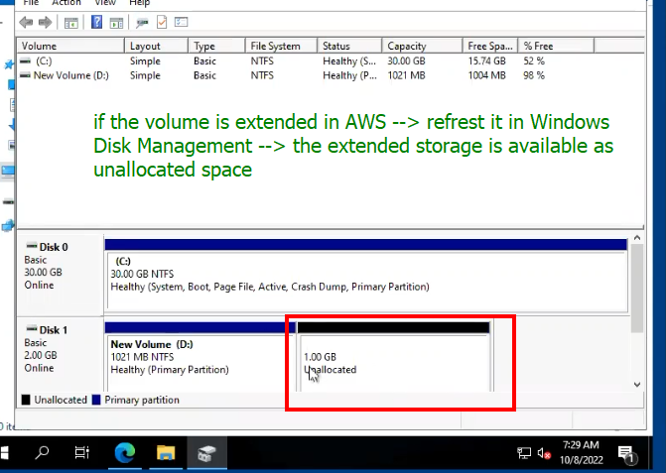
* .
* Create new volume from this unallocated storage. But don’t format it.
* 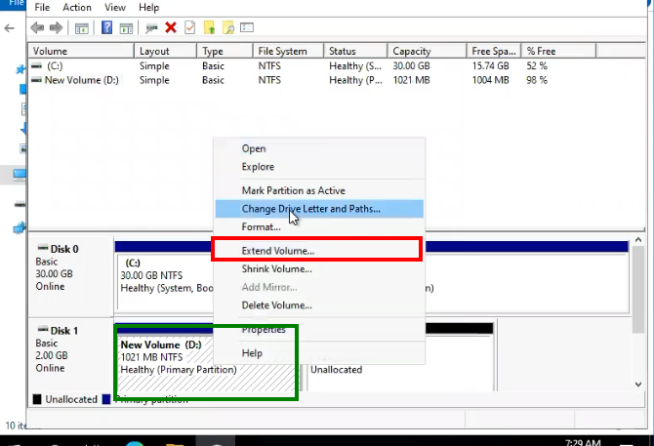
* After that, extend the extend volume.
* 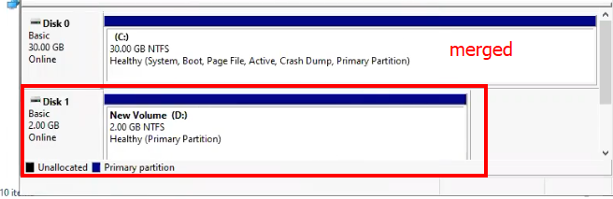
* . volumes are merged into 1 Disk.
* Next topic 🡪 multi-pathing (for redundancy)
* 
 
 